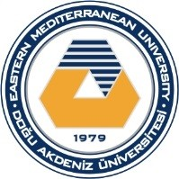

Department of Civil Engineering

Eastern Mediterranean University

Spring 2025‐2026

HIGHEST CONCRETE STRENGTH and permeabılıty COMPETITION 2026

Design & make your own concrete! Impress your friends! Break stuff!

Apply until 3rd May 2026

Participants will be from Civil Engineering Department Undergraduate students of EMU. Teams can be up to 3 persons. Kindly visit the Department of Civil Engineering website to fill out and submit the application for the competition online (https://civil.emu.edu.tr/en/forms/highest-concrete-strength-and-permeability-competition) until 3rd May 2026 (by 17:00 hours)
Evaluation will be based on highest concrete compressive strength and highest permeability among all results after 7 days of casting concrete cube. Certificates (first rank, second rank, third rank, and all participants) will be given during Civil Engineering Week of 2026.

Rules

- Limit 1 specimen per entry, a 150 mm cube mold will be provided.
- Limit 1000 g Portland cement, to be provided by EMU Department of Civil Engineering.
- Limit 1 batch per specimen (do not waste your cement!).
- Concrete must be mixed by hand‐tools, supervised in the Materials of Construction Lab.
- Curing:
o Any curing method in lab.
o Cube must be at or near room temperature at the time of testing
o No external loads may be applied during curing
- Laboratory materials available: Type I Cement 42.5 R, crushed fine and coarse limestone aggregates, water.
- Any other materials (admixtures, fibers, etc.) will not be allowed.

