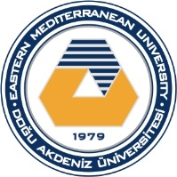
Department of Civil Engineering
Eastern Mediterranean University
Spring 2021-2022
HIGHEST CONCRETE STRENGTH COMPETITION 2022
APPLICATION FORM
This form should be sent by e-mail to ozgur.eren@emu.edu.tr until 25 March 2022 (by 17:00 hours).
Team  members | i.d. number | name | surname | e-mail | Cell-phone
1
2
3
Date applied | D/M/2022

