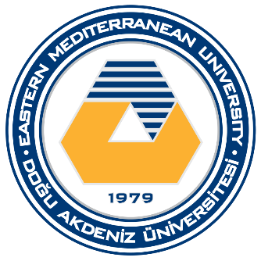
Department of Civil Engineering
Eastern Mediterranean University
Spring 2023-2024
HIGHEST CONCRETE STRENGTH COMPETITION

APPLICATION FORM

This form should be sent to Prof.Dr. Khaled Marar until 19th April 2024 (by 17:00 hours) by email (khaled.marar.emu.edu.tr).
Team  members | ID Number | Name | Surname | E-Mail |  | Cell-Phone
1
2
3
Date applied | D/M/2024

